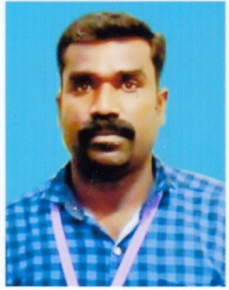

**STAFF PROFILE**

|  |  |  |
| --- | --- | --- |
| Name | : | **Mr.G.MOHAN** |
| Designation | : | **Sports Trainer** |
| Qualification | : | **B.A.,B.P.Ed.,M.P.Ed.,** |
| Experience | : | **7 Years 3Months** |
| **Sports Achievement** | | |
| Inter – collegiate Bharathiyar University Volleyball Tournament - Third Position (2003-2004) | | |
| Inter – collegiate Bharathiyar University Athletics Tournament –  (100 mts) - Third Position (2003-2004) | | |
| Inter – collegiate Bharathiyar University Athletics Tournament –  (4x100 mts) Really - Third Position (2003-2004) | | |
| State Level Ball Badminton Inter Physical Education Tournament Runner-up (2002-2003) | | |
| State Level Volleyball Inter Physical Education Tournament Runner-up (2002-2003) | | |
| State Level Cricket Inter Physical Education Tournament Winner (2001-2002) | | |